**PH 115 Lab Report 1**

|  |  |
| --- | --- |
| **Names** | **Percent** |
| Nolan Anderson - Section 115 - 12 | 16.6% |
| Stephen Stammen | 16.6% |
| Paul Zorovich | 16.6% |
| Byron Thompson | 16.6% |
| Bradley Fleming - Section 115 - 10 | 16.6% |
| Daniel Mills | 16.6% |

**[Q1-Lab/Demonstration]**

**1a)** The Orange/Yellow lines are water and the Blue/Grey lines are oil. This is because water has a higher heat capacity than oil.

**1b)** Probably not, because the water heats up faster than the oil within the first couple of minutes.

**1c)** At the surface, the temperature is more consistent, so the oil’s shallow probe is the grey line and the water’s shallow probe is the orange line. Closer to the heat source, the temperature can change rapidly, so the oil’s deeper probe is the blue line and the water’s deeper probe is the yellow line.

**[Q2-Home]**

Water deviates from a straight line in plot of “temperature vs time” for a few reasons. The first reason it deviates compared to oil is that oil is a more viscous material meaning it’s thicker and has larger molecules, which allows it to heat more evenly. A second reason for the slight deviation from a smooth curve could be a result of the one probe being closer to the heat source, which allows it to have a more rapid change in temperature than the higher probe, which will be reading a temperature more consistently. Lastly, when the water is heated, the higher temp water will rise and the lower temperature water will be forced down to the bottom of the container. This will cycle until the water has reached a homogenous temperature. All three of these reasons contribute to the unsteady curve for the graph of water.

**[Q3-Home]**

mc=3.7 Kg ti=289.15 Kelvin

mw=13 Kg tf=291.15 Kelvin

mm=2.4 Kg tm=439.15 Kelvin

cw=4180 J/Kg Kelvin

cm=mwcw(tf - ti)/(mmtm - mmtf - mctf + mcti)

The Specific heat of the metal is **312.4784 J/Kg Kelvin**

**[Q4-Home]**

Ice and water have the same heat of fusion because they are, essentially, the same element. The heat of fusion would be negative when going from water to ice. An important implication for life on earth is that ice will naturally absorb heat, but for the reverse process, you must make the surroundings more cold in order for the water to turn into ice. This is why freezing water takes energy from your refrigerator, but you can just leave ice on the counter and it will melt naturally.

**[Q5-Lab/Demonstration]**

**5a)**. 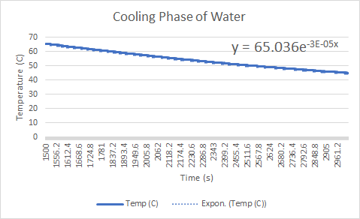

**5b)** The cooling rate of water can be acquired from fitting an exponential trend line to the data in the graph above which is $3 ×10{}^{-5}$ 1/s.

**5c) $B=\frac{hA}{mC_{p}}$**

We are given h = 0.6 $\frac{W}{mK}$, $A=π(0.04)^{2}$, m = 200 g, $C_{p}=4.18 \frac{J}{gC{{}^{∘}}^{}}$, and a distance of 0.02 m beneath the surface of the fluid to the end of the probe. Plugging the values into the equation we get the theoretical cooling rate.

$\frac{(\frac{0.6W}{0.02mK})(0.0050265m^{2})}{(200 g)(4.18 \frac{J}{gC^{∘}})}=1.8 x 10^{-4}$

The theoretical value for the cooling rate is higher than the experimental so the total temperature drop and rate should be slightly more than what is acquired in the experiment.

**[Q6-Home]**

Ta=20 C

T(0) = 80 C

T(2) = 60 C

T(t)=Ce-kt+Ta

Step 1: Find C Step 2: Find K

T(0)=Ce-kt+Ta T(2)=Ce-kt+Ta

80=(C*~~e~~~~-k*0~~1)+20 60=60e-2k+20

60 = C 40=60e-2k

⅔=e-2k

Ln ⅔ = -2k

K = (-ln 2/3)/2

Step 3: find t where T(t)=40

40=60e(-ln2/3)/2*t+20

20 = 60e(-ln2/3)/2*t

⅓ = e(-ln2/3)/2*t

Ln ⅓ = (-ln 2/3)/2 * t

t= 2ln(⅓)/ln(⅔)

T = 5.42

The Liquid will cool to 40 degrees in **5.42 minutes**

**[Q7-Home HL Bonus]**

Newton’s Law of Cooling says that the greater the difference between the temperature of the coffee and room temperature, the faster it will cool. Therefore, if you wait ten minutes before adding the cream, the coffee will cool quickly and then adding the cream will cause it cool even more. If you add the cream first, the coffee will still cool, but at a much slower rate. Supposing “better” in this instance means that the coffee is hotter for longer, then putting the cream in first is the “better” option. After ten minutes, the coffee with cream put it in first will be the warmest.

**[Q8-Home]**

$B=\frac{kA}{mC_{p}}$; A is in L^2, m is in L, Cp is in W/mK; K is in W/(m^2K)*B

$K =\frac{W}{m^{2}K}B=\frac{Wm^{2}}{m^{2}K}/m(\frac{W}{mK}) =\frac{W}{K}/\frac{W}{K}=1$ Therefore, the equation is dimensionally correct.

**[Q9-Demonstration]**

What is happening to the temperature of the water when the salt is added that it depresses the freezing point of water so that it can go below 32℉ before it turns to ice. Which is very helpful with icy roads. Naturally, you will have more grip with your tires on water than ice. Salt on roads makes it so that the water does not turn to ice until it gets *much* cooler.

**[Q10-Home HL Bonus]**

Let ‘l’ be the length of the inclined plane. Since the coefficient of friction is ‘μ’, the work done by the friction force is converted into heat energy . This is utilized to melt the ice block of mass

‘ $m_{0}$’. The friction force(f)= $μN$, where $N=m_{0}gCos(ϕ)$. So, $f=μm_{0}gCos(ϕ).$

If $L_{f}$ is latent heat of fusion for water, then in order to melt the ice block completely, the work done by friction must be equal to $m_{0}L_{f}$.

Therefore, $f=m_{0}L_{f}→l={(m}_{0}L_{f})/(μm_{0}gCos(ϕ))$

After cancelling out the initial mass from the top and bottom, the answer is:

$l=L_{f}/(μgCos(ϕ))$

**[Q11-Lab]**

**11a)**

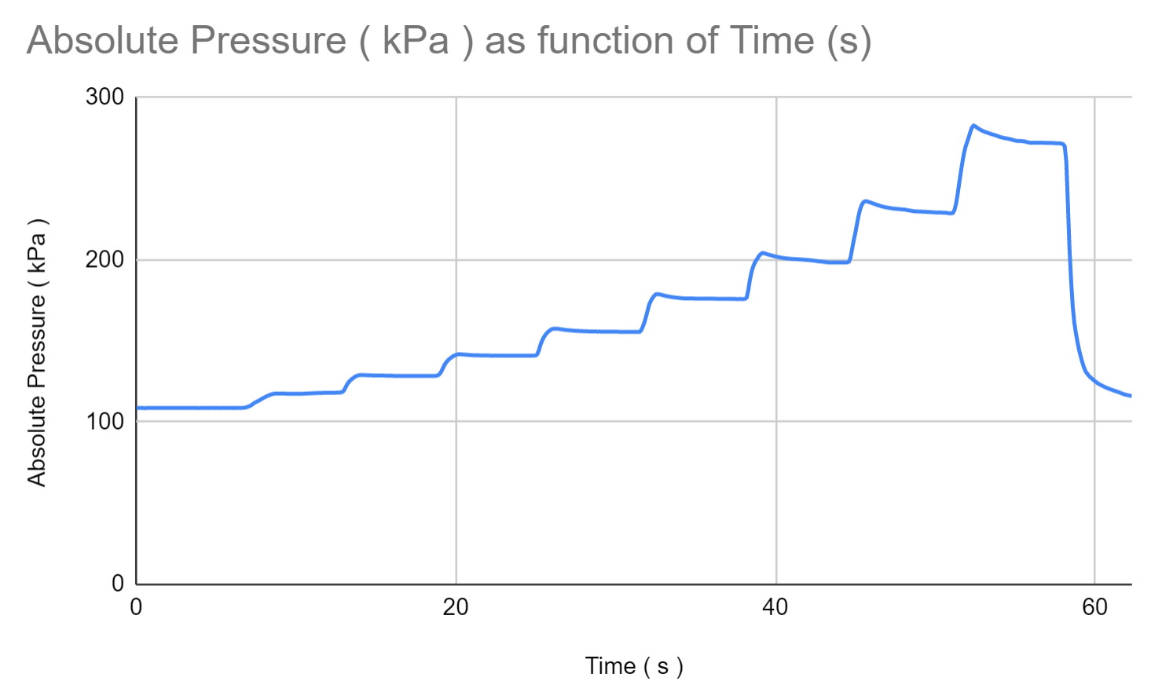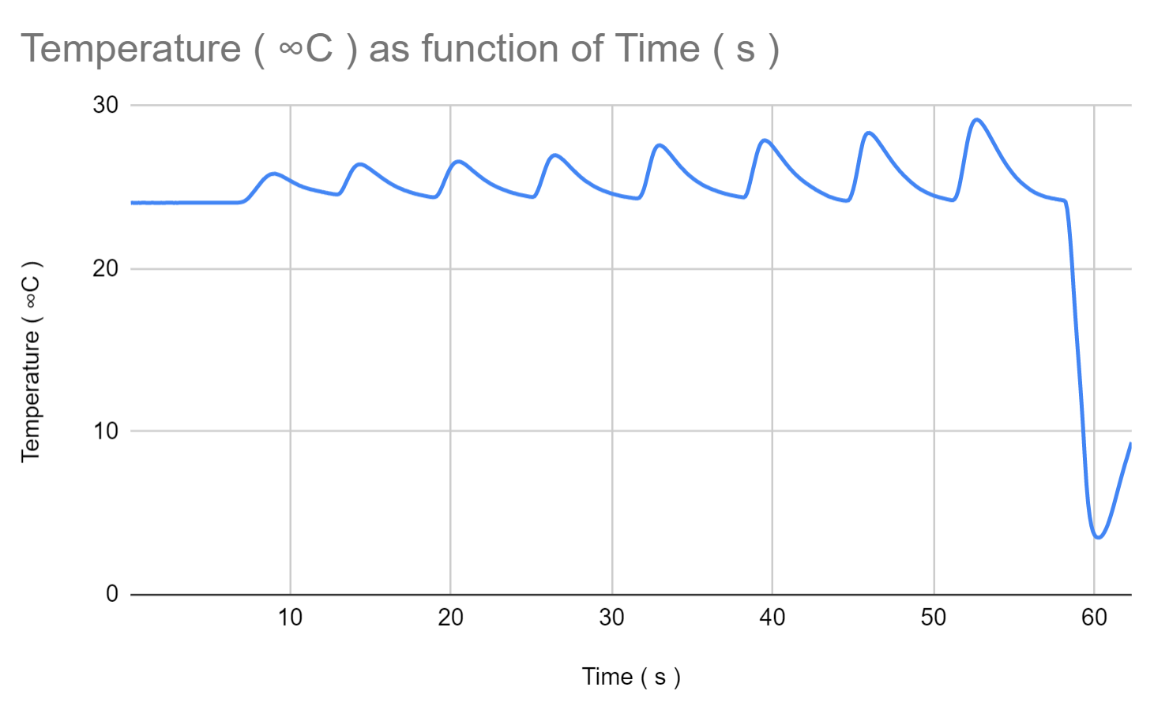

**11b)**

Values of pressure to use in order to verify Boyle's law. Explain and plot the resultant PV diagram. Boyle’s law demonstrates volume decreases as pressure increases. The P and V on the left side of PV=nRT are an inverse relationship. The pressure values should be taken moments after each peak in the graph so that it has a bit of time to normalize, but not enough for pressure to decrease too much due to leaking.

P1 = 117.5 - V1 = 60

P2 = 128.75 - V2 = 55

P3 = 141 - V3 = 50

P4 = 155.75 - V4 = 45

P5 = 176 - V5 = 40

P6 = 200.25 - V6 = 35

P7 = 231.75 - V7 = 30

P8 = 277.5 - V8 = 25

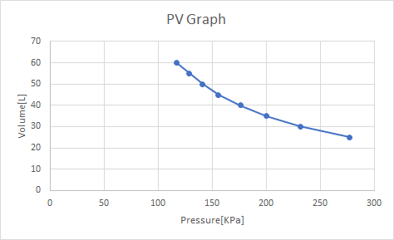

Boyle’s law is shown true at these values because when the volume decreases, the pressure increases proportionally as shown on the graph.

**11c)**

To find the number of air molecules exist in this syringe use $PV=nRT$

$t = 20 sec$

$T = 26.24 C = 299.24 K$

$P = 141.43$ kPa

$R = 8.315 \frac{J}{mol ⋅ K}$

$P(\frac{55 mL}{1000 mL}) = n(8.315 \frac{J}{mol ⋅ K} )(26.24°C + 273K)$

$n = \frac{141.43 * .055L}{8.315 \frac{J}{mol*K} * 299.24 K}$

$n = \frac{141.43 kPa ×0.055 L}{8.315 J/mol K)(299.24K)} = .00313 mol$

**[Q12-Lab]**

**12a)** This is the first law of thermodynamics at work. As you compress something in an adiabatic process, the internal (heat) energy rises. Therefore, when you decompress the piston the opposite happens and you get an extreme decrease in temperature, i.e. internal energy.

**12b)**

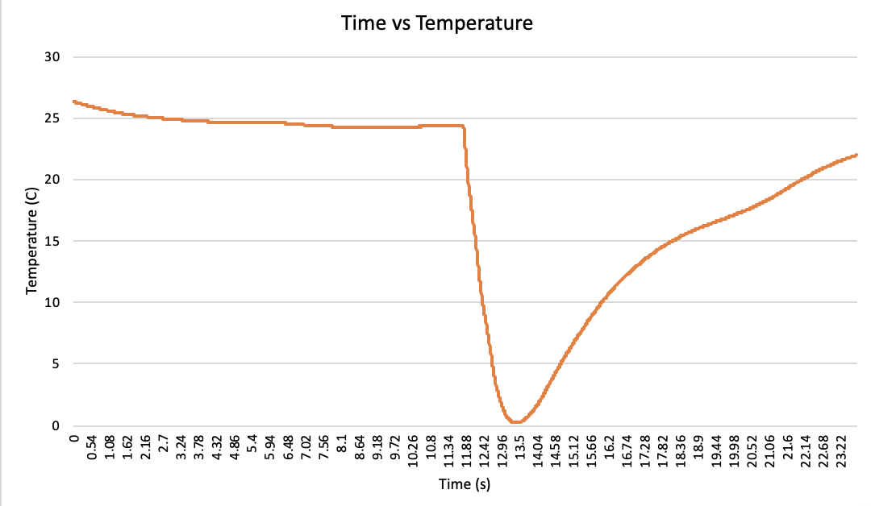

**12c)** On this graph, the temperature is dependent on the volume of the piston. In this case, as time increases the temperature changes. Due to Polytropic processes, the temperature falling shows us that there is a rapid increase in volume. After the temperature reaches 0, the temperature begins to increase again as the system is equalizing itself.

From the wiki page:

---

Under the assumption of [ideal gas law](https://en.wikipedia.org/wiki/Ideal_gas_law), heat and workflows go in the same direction (*K* < 0), such as in an [internal combustion engine](https://en.wikipedia.org/wiki/Internal_combustion_engine) during the power stroke, where heat is lost from the hot combustion products, through the cylinder walls, to the cooler surroundings, at the same time as those hot combustion products push on the piston.

---

Essentially, the temperature change pushes on the piston, which is why you see the temperature eventually increase because the volume has increased.

**[Q13-Home HL Bonus]**

pV = C; p = 150 kPa; V = 600cm^3; dp/dt = 20

p(dp/dt)V(dV/dt) = 0, solve for dV/dt.

150(20) * 600(dV/dt) = 0

600(dV/dt) = -3000

dV/dt = -12000/600 = -5cm^3/min

**[Q14-Home HL Bonus]**

Gear: r: .02m, m: 50g

Efficiency: $\frac{(95-55) C^{∘}}{368 K}=10.8\%$

E: $30 KJ/g * 10 g = 300 KJ$

Rotational Energy: Efficiency $×$ E => $0.108 * 300 KJ =32.4 KJ$

Angular Velocity: $\sqrt{\frac{2E}{\frac{1}{2}m{r^{2}}^{}}}$ => $\sqrt{\frac{32400}{0.050{(0.02)}^{2}} } =$ 40249 rad/s

**[Q15-Home]**

